# Numerical Method to PDEs, HW2

Problem 1:

1. The numerical solution using Crank-Nicolson Method and the corresponding Errors are shown in the figure below

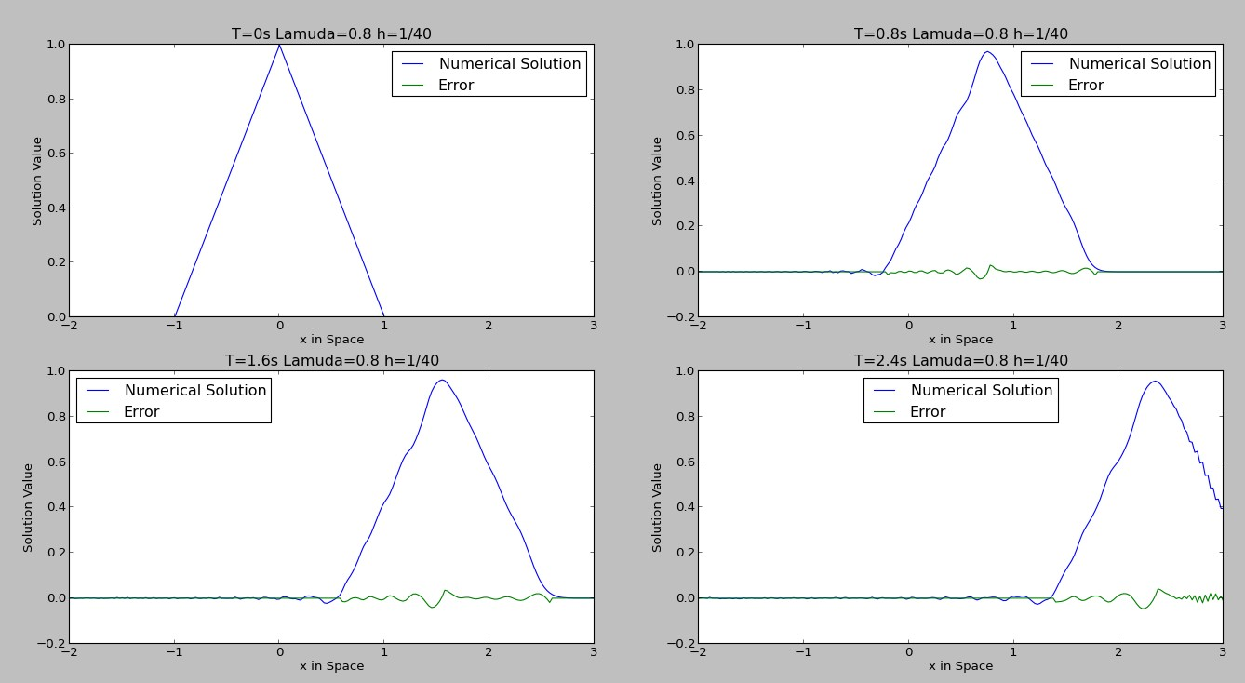

1. The numerical solution using BTCS Method and the corresponding Errors are shown in the figure below

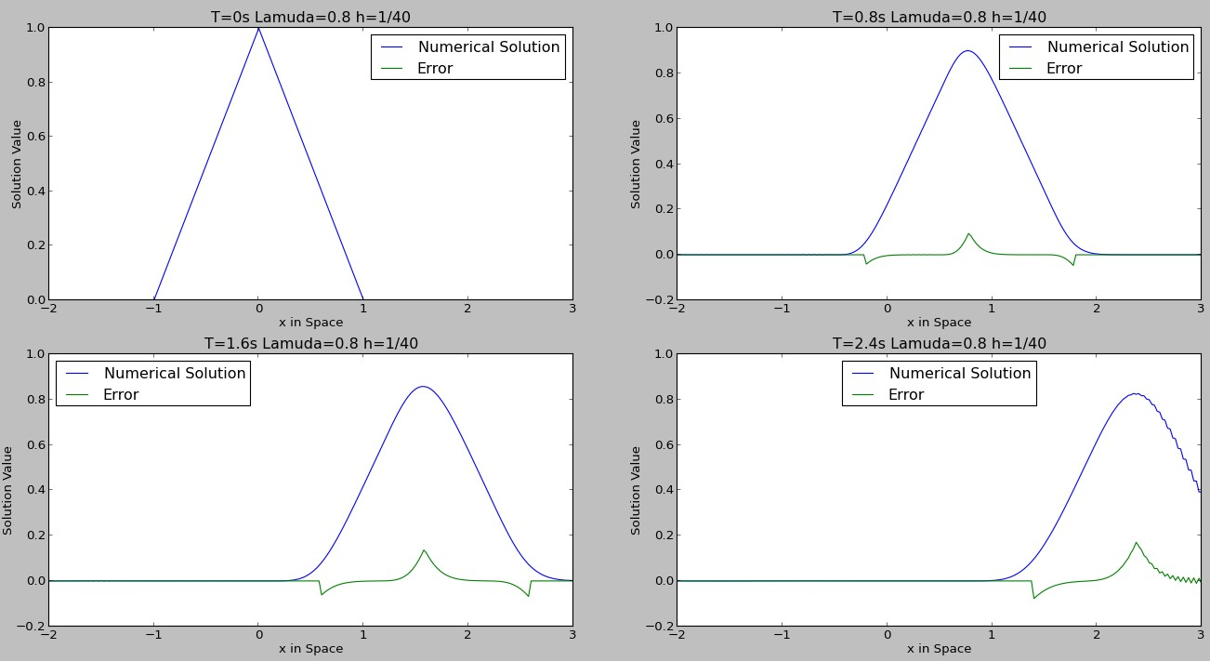

1. Based on the figure above, we can see that at any time point, the error from CN is smaller than the error from BTCS, which means that CN is more accurate than BTCS
2. 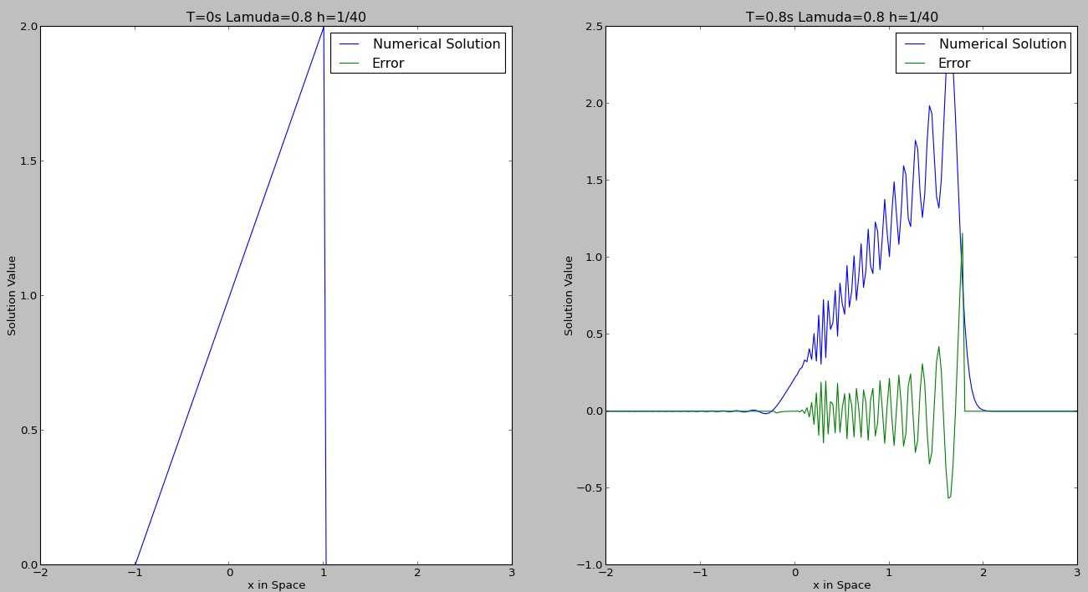As we can see from the figure, if monotone initial data is put, the result is not monotone by using CN, therefore it is not monotone method.

Problem 2:

1. By choosing ε=0.005 , we can observe the effect of dissipation as below:

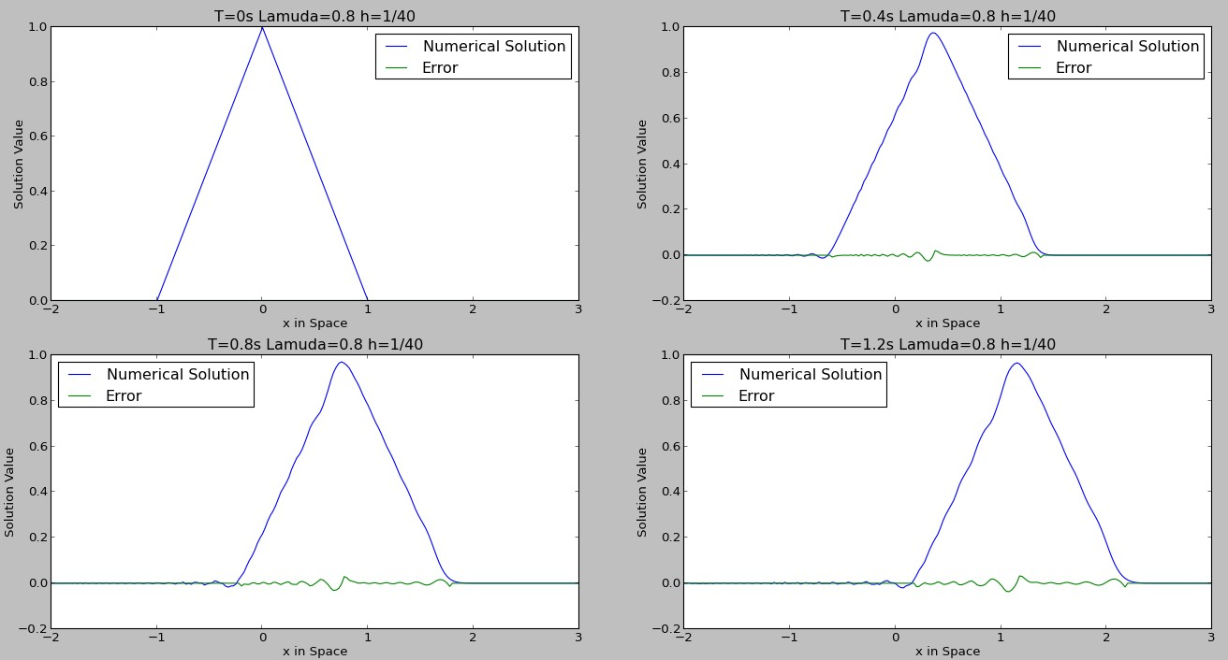

1. By choosing ε=0.05 , we can observe the effect of dissipation as below:

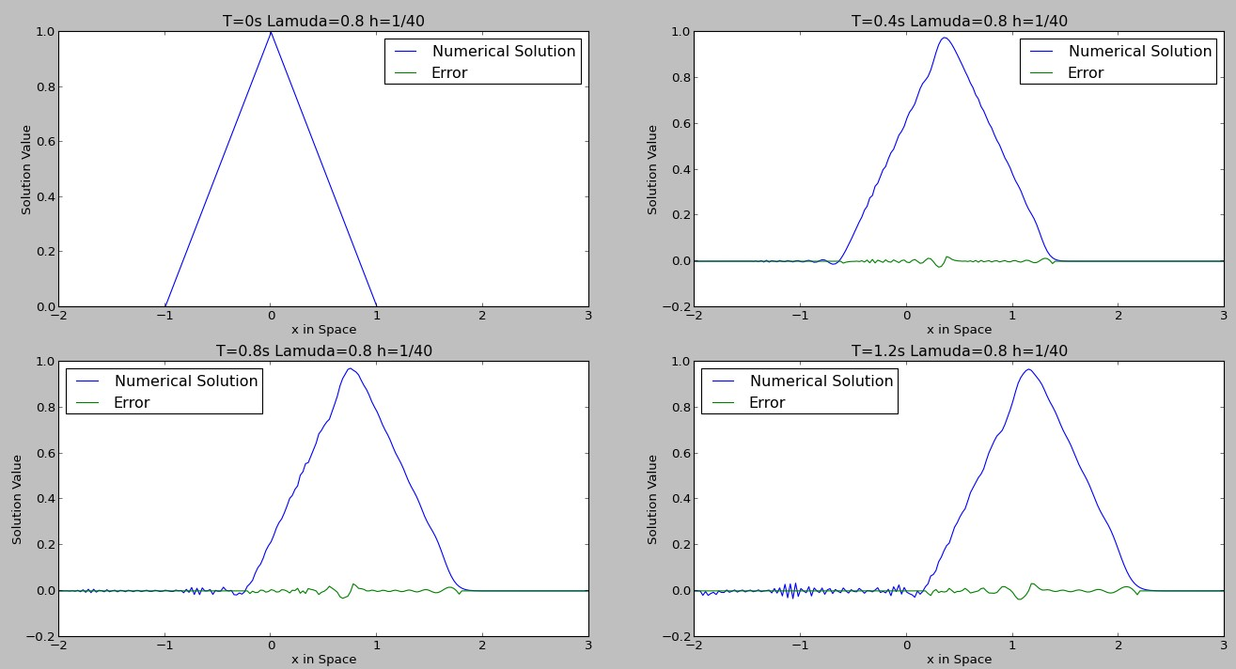

1. By choosing ε=0.1 , we can observe the effect of dissipation as below:

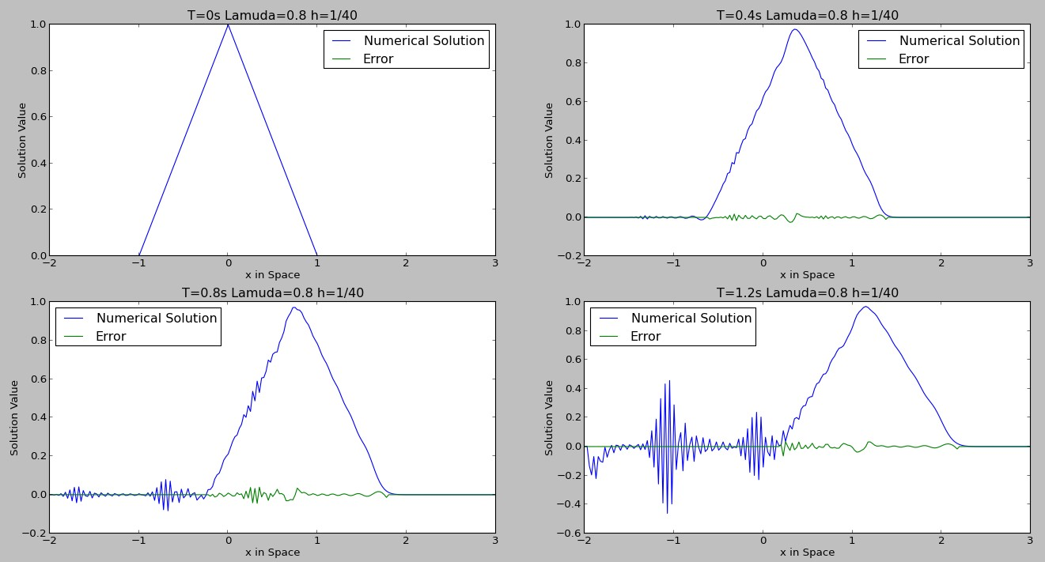

1. By choosing ε=0.15 , we can observe the effect of dissipation as below:

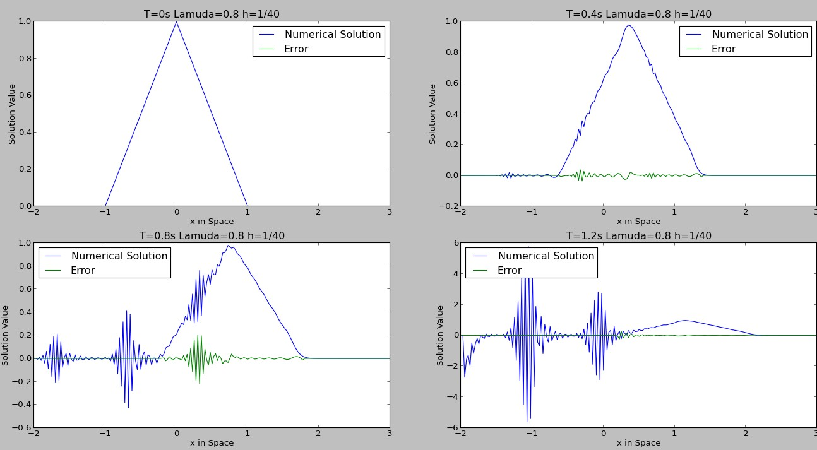

1. Therefore we came to the conclusion that with larger ε, the dissipation effect is larger. Also, as time propagates, the dissipation effect grows larger with any arbitrary value of ε.

Problem 3:

1. The numerical solution and the error and wave packet is plotted as below

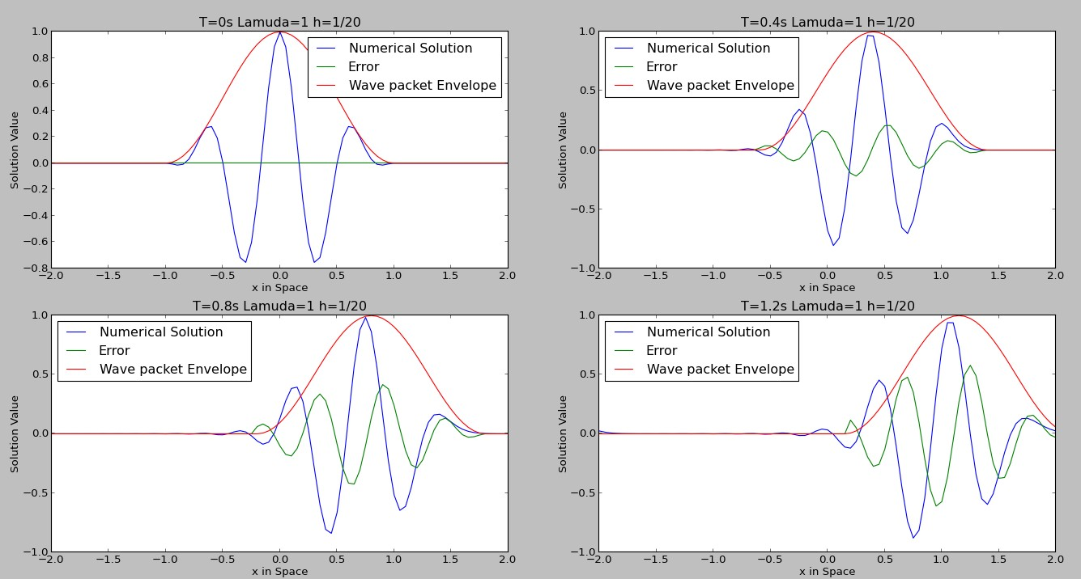

We can calculate the group velocity = 0.8464

With this velocity, the center of the wave packet for the above case should be at x=0, x= 0.4 , x=0.8 , x=1.2 correspondingly.

From the figures we can see that the center of the numerical solution corresponds very well to the value calculated above.

1. The Numerical solution and high frequency part is plotted as below:

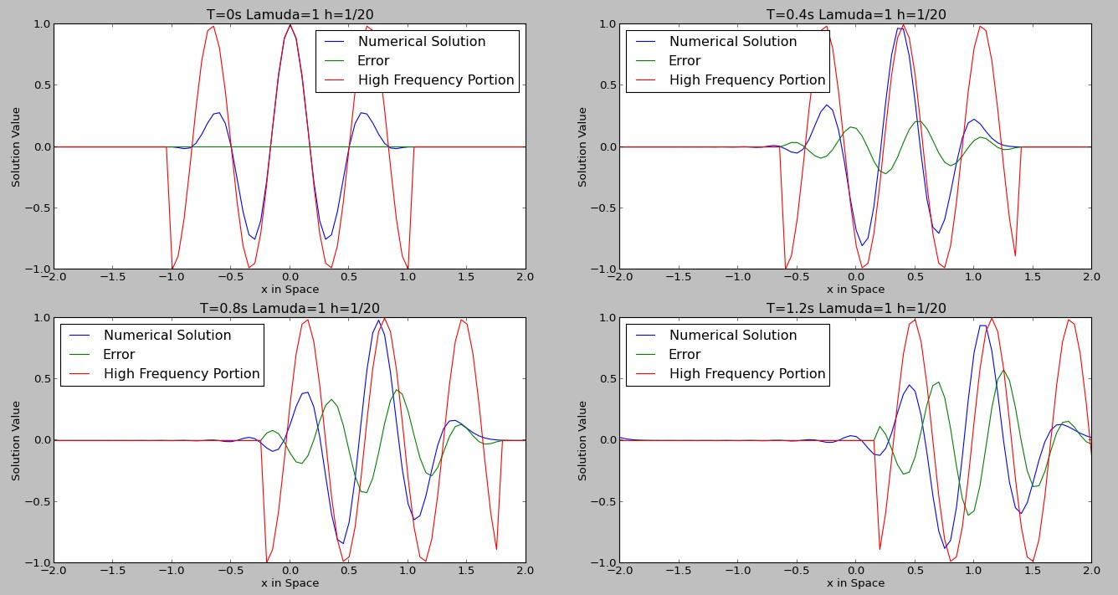

We can calculate the phase velocity = 0.9448

With this velocity, the center of the High frequency part for the above case should be at x=0, x= 0.378 , x=0.756, x=1.134 correspondingly.

From the figures we can see that the high frequency portion of the wave corresponds very well to the value calculated above.

Problem 4:

1. At t=0 , the solution is plotted as below:

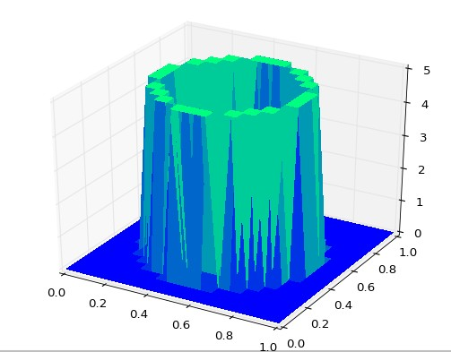

At t =0.25s, the solution is plotted as below:

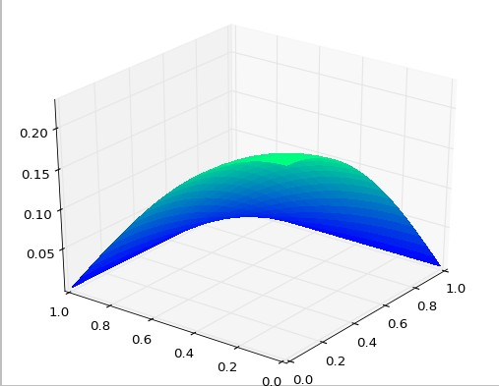

At t=0.5s, the solution is plotted as below:

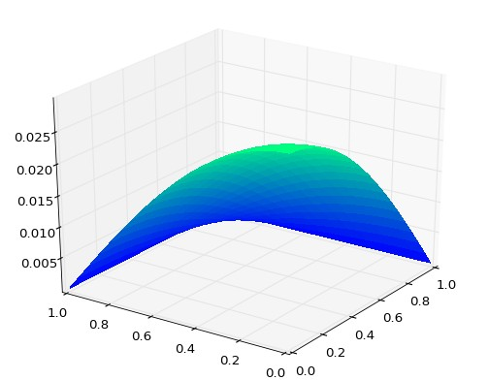

At t =0.75s, the solution is plotted as below:

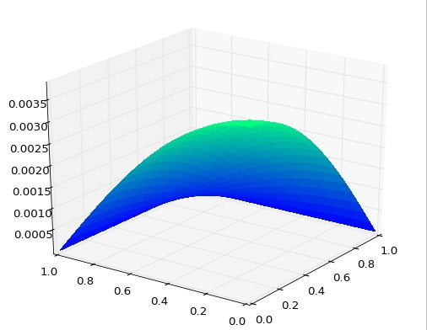

At t =1s, the solution is plotted as below:

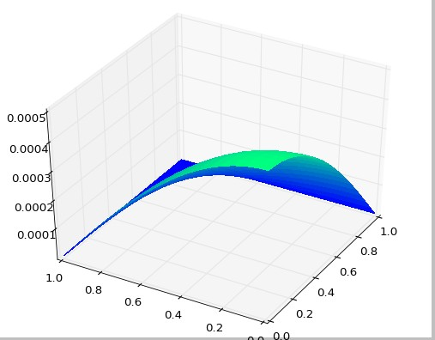

As can be seen and also from further exploration onto the data, we will see that the maximum temperature get less than 0.001 when t-0.93s. This value may also change if different time step or h is used.

1. By using µ=20 and h=0.05 (λ=1), which violates the maximum principles, we will have the following result at different time steps:

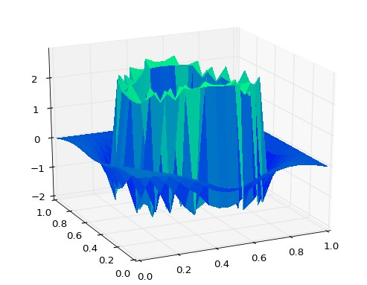At t = 0.25

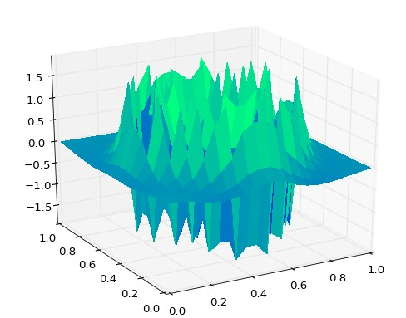 At t=0.5

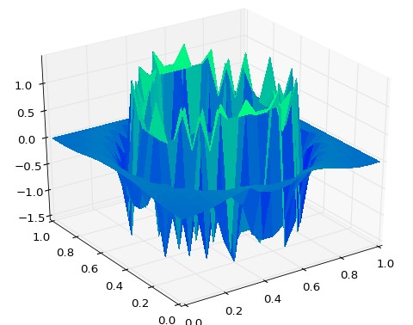At t=0.75

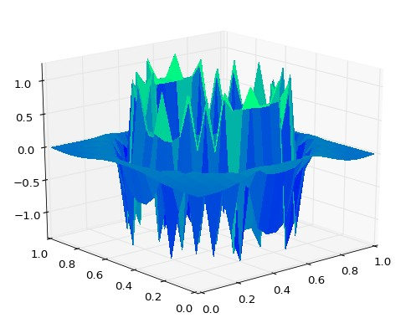 At t=1

Thus we can see that by using a step-size combination that violates the conditions for the numerical maximum principle, the solution blows up.

1. The sparsity pattern of the unfactored matrix is as:

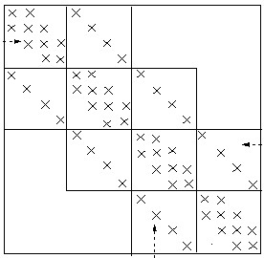

C:\Users\ZC2012\AppData\Roaming\Tencent\Users\303500280\QQ\WinTemp\RichOle\MY_MLUE2(`{1MG%U96KDBA2.jpg

C:\Users\ZC2012\AppData\Roaming\Tencent\Users\303500280\QQ\WinTemp\RichOle\MY_MLUE2(`{1MG%U96KDBA2.jpg

C:\Users\ZC2012\AppData\Roaming\Tencent\Users\303500280\QQ\WinTemp\RichOle\MY_MLUE2(`{1MG%U96KDBA2.jpg

The Original Sparsity of LU factors can be stated as below:

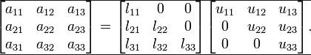

In the current case of block triangular matrix, the pattern can be drawn

C:\Users\ZC2012\AppData\Roaming\Tencent\Users\303500280\QQ\WinTemp\RichOle\UVZD7TQC(C)W4I`J5M_W_E2.jpgC:\Users\ZC2012\AppData\Roaming\Tencent\Users\303500280\QQ\WinTemp\RichOle\UVZD7TQC(C)W4I`J5M_W_E2.jpgC:\Users\ZC2012\AppData\Roaming\Tencent\Users\303500280\QQ\WinTemp\RichOle\UVZD7TQC(C)W4I`J5M_W_E2.jpgC:\Users\ZC2012\AppData\Roaming\Tencent\Users\303500280\QQ\WinTemp\RichOle\UVZD7TQC(C)W4I`J5M_W_E2.jpgas below :

|  |  |  |  |  |  |  |  |
| --- | --- | --- | --- | --- | --- | --- | --- |
| x | x |  |  | x |  |  |  |
|  | x | x |  |  | x |  |  |
|  |  | x | x |  |  | x |  |
|  |  |  | x | x |  |  | x |
|  |  |  |  | x | x |  |  |
|  |  |  |  |  | x | x |  |
|  |  |  |  |  |  | x | x |
|  |  |  |  |  |  |  | x |

Shown above is the U matrix

|  |  |  |  |  |  |  |  |
| --- | --- | --- | --- | --- | --- | --- | --- |
| x |  |  |  |  |  |  |  |
| x | x |  |  |  |  |  |  |
|  | x | x |  |  |  |  |  |
|  |  | x | x |  |  |  |  |
| x |  |  | x | x |  |  |  |
|  | x |  |  | x | x |  |  |
|  |  | x |  |  | x | x |  |
|  |  |  | x |  |  | x | x |

Shown above is the L matrix.

As a property of LU factorization, if we assume the number of nodes at x and y is N, then the bandwidth of the matrix before being factored is (2N+1). Also, the bandwidth of matrix after being factored is (N+1) for each L and U matrix.